Problems
Now write and execute SQL queries to solve assignment problems

Problem 1
Find the total number of crimes recorded in the CRIME table.
ANSWER: 533
select count(CASE_NUMBER) from chicago_crime

Problem 2
Retrieve first 10 rows from the CRIME table.
select * from chicago_crime limit 10

Problem 3
How many crimes involve an arrest?
ANSWER: 163
select COUNT(CASE_NUMBER) from chicago_crime
WHERE ARREST='TRUE'

Problem 4
Which unique types of crimes have been recorded at GAS STATION locations?
Click here for a hint
ANSWER 6

select COUNT(CASE_NUMBER) from chicago_crime
where LOCATION_DESCRIPTION="GAS STATION"

Problem 5
In the CENUS_DATA table list all Community Areas whose names start with the letter 'B'.
select * from chicago_socioeconomic_data
where COMMUNITY_AREA_NAME like 'B%'

Problem 6
Which schools in Community Areas 10 to 15 are healthy school certified?
ANWER: “Rufus M. Hitch”

SELECT * FROM chicago_public_schools
WHERE COMMUNITY_AREA_NUMBER BETWEEN 10 AND 15
AND HEALTHY_SCHOOL_CERTIFIED = 'YES';

Problem 7
What is the average school Safety Score?

Answer: 49,504
select avg(safety_score) as 'Average safety score in schools' from chicago_public_schools;

Problem 8
List the top 5 Community Areas by average College Enrollment [number of students]
select COMMUNITY_AREA_NAME, avg(COLLEGE_ENROLLMENT) from chicago_public_schools
group by community_area_name
order by avg(COLLEGE_ENROLLMENT) desc limit 5
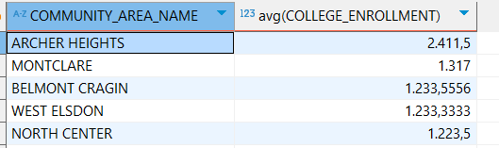

Problem 9
Use a sub-query to determine which Community Area has the least value for school Safety Score?
select community_area_name,safety_score from chicago_public_schools
where safety_score = (select MIN(safety_score) from chicago_public_schools)
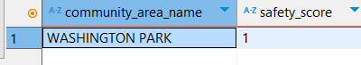

Problem 10
[Without using an explicit JOIN operator] Find the Per Capita Income of the Community Area which has a school Safety Score of 1.
select PER_CAPITA_INCOME from chicago_socioeconomic_data,chicago_public_schools
where chicago_socioeconomic_data. COMMUNITY_AREA_NUMBER=chicago_public_schools.COMMUNITY_AREA_NUMBER
and chicago_public_schools.safety_score =1

